CONVENTION FOR THE SAFEGUARDING OF THE
INTANGIBLE CULTURAL HERITAGE
INTERGOVERNMENTAL COMMITTEE FOR THE
SAFEGUARDING OF THE INTANTINGIBLE CULTURAL HERITAGE
Fifth session
Nairobi, Kenya
15 to 19 November 2010
GENERAL INFORMATION
This document provides necessary information on travel to Nairobi and the fifth session of the Intergovernmental Committee. This information is also available at the following address:
www.unesco.org/culture/ich/en/5COM/
This website has a link to the website of the Kenyan host authorities with information regarding the venue and recommended accommodation.
www.intangibleculture.go.ke,

TABLE OF CONTENTS
1. FIFTH SESSION 3
2. HOST COUNTRY RESPONSIBLES 3
3. REGISTRATION 3
4. ACCOMMODATION 4
5. PASSPORT, VISA AND OTHER TRAVEL INFORMATION 4
5.1 Information about travelling to Kenya 4
5.2 Passport Requirements 4
5.3 Visa Requirements 5
5.4 Getting to Nairobi/Kenya 6
5.5 Medical Insurance 6
5.6 Information on Public Health and Vaccination 7
6. THE MEETING 7
6.1 Meeting Venue 7
6.2 Getting to the Meeting Venue 7
6.3 Meeting Check-in Desk and Badges 7
6.4 Meal Brakes 8
6.5 Participants Lounge 8
7. DESTINATION INFORMATION: NAIROBI, KENYA 8
7.1 Introduction to Kenya 8
7.2 Introduction to Nairobi 9
7.3 Local Transportation 9
7.4 Currency and Exchange 9
7.5 Tipping 10
7.6 Driving in Kenya 10
7.7 Electricity Supply 10
7.8 Postal Service 10
7.9 Telephone Service 10
7.10 Time 11
7.11 Drinking Water 11
8. SOCIAL PROGRAMME AND RELATED EVENTS 11

LIST OF ANNEXES
Annex A: Registration Form for the fifth session of the Committee 13
Annex B: Recommended Hotels 15
Annex C: Map of Nairobi 19

1. FIFTH SESSION
The fifth session of the Intergovernmental Committee will be held in Nairobi, Kenya, from Monday 15 to Friday 19 November 2010 at the Kenyatta International Conference Centre. All relevant information is also available at: http://www.unesco.org/culture/ich/en/5COM/.
The Intergovernmental Committee for the Safeguarding of the Intangible Cultural Heritage consists of 24 representatives from the States Parties to the Convention for the Safeguarding of the Intangible Cultural Heritage, elected by the General Assembly of States Parties to the Convention.
The current composition of the Committee is: (Group I) Cyprus, Italy, Spain, (Group II) Albania, Azerbaijan, Croatia, Czech Republic, (Group III) Cuba, Grenada, Nicaragua, Paraguay, Venezuela (Bolivarian Republic of), (Group IV) China, Indonesia, Iran (Islamic Republic of), Japan, Republic of Korea, (Group V(a)) Burkina Faso, Kenya, Madagascar, Niger, (Group V(b)) Jordan, Morocco, Oman.
The elected Members (decision 4.COM 23) of the Bureau of the fifth session of the Committee are:
- Chairperson: Dr Jacob Ole Miaron (Kenya)
- Vice-Chairs: Cyprus, Croatia, Republic of Korea and Oman
- Rapporteur: Ms Margarita Ruiz Brandi (Cuba)
The working languages are English and French.
In addition, interpretation will be made available in:
Arabic: thanks to the generous support of the United Arab Emirates authorities
Spanish: tanks to the generous support of the Government of Spain
2. HOST COUNTRY RESPONSIBLES
Kenya, Ministry of State for National Heritage and Culture
Address: P.O. Box 49849-00100
Nairobi, Kenya
Tel: +254 20 2251164, 2251005, 2250576
Fax: +254 20 316187
E-mail: info@nationalheritage.go.ke

Project Director: Gladys Gatheru (Mrs.)
Tel: +254 20 2727980-4
Fax: +254 20 2725329
e-mail: ggwangechi@yahoo.co.uk

Executive Coordinator: John Moogi Omare
Tel: +254 20 2727980-4
Fax : +254 20 2725329
e-mail : ojohnmoogi@gmail.com
3. REGISTRATION
All delegates, observers and those who wish to attend the fifth session of the Committee are strongly advised to register as soon as possible and no later than 15 October 2010. This will provide the session organizers with sufficient time to process information and prevent any inconvenience to participants. Please register on line on the website of the Convention at: http://www.unesco.org/culture/ich/fr/5COM/.
If you cannot register on line, please use the registration form in Annex A and return it by fax to +33(0)1 45 68 57 52, or by e-mail to: ichmeetings@unesco.org.
It is of the utmost importance that registered participants inform the Intangible Cultural Heritage Section of any subsequent changes made to their travel arrangements. This will help ensure that logistical arrangements are carried out smoothly.
4. ACCOMODATION
For the convenience of participants to the meeting, the organizers have established a website with a link to hotels in Nairobi, throughout the duration of the meeting. The hotels are located in eight different areas of the city:

- Intercontinental Hotel
- Nairobi Serena Hotel
- Hilton Hotel
- Crowne Plaza
- The Sarova Stanley
- Fair View Hotel
- Sarova Panafric Nairobi
- Silver Springs Hotel
Participants who stay at any of the recommended hotels specified in Annex B will be provided with a shuttle service between their hotel to the meeting venue and back.
Special rates have been negotiated for the participants. To book a room at one of these hotels and benefit from these rates, participants must indicate the booking code “UNESCO Meeting”.
For more information about the recommended hotels see Annex B and the website of the host country organizer www.intangibleculture.go.ke.
Session participants are responsible for booking their own hotel room and for covering all costs related to their accommodation incurred during their stay. Usually a credit card number will be required by hotels to reserve a room.
Please note that the number of hotel rooms available is limited.
5. PASSPORT, VISA AND OTHER TRAVEL INFORMATION
5.1 Information about travelling to Kenya
It is strongly recommended that session participants contact the Kenya Consular Services in their own country for further information about entry requirements, procedures and visa costs. A list of the Kenya Missions abroad can be found at the Ministry of Foreign Affairs website from the Republic of Kenya at
http://www.mfa.go.ke/mfacms/index.php?option=com_content&task=view&id=17&Itemid=29&limit=1&limitstart=1.
5.2 Passport Requirements
- Valid passports or other travel documents including Seaman’s Discharge Book, acceptable to the Government of Kenya are required for all persons wishing to enter Kenya.
- No official endorsement should be indicated on Passports issued by the Governments not recognized by the Government of Kenya as valid travel documents; instead, a paper visitor’s pass should be issued therein.
- Passports must be valid for at least six (6) months.
- Passports must have a clean and a full visa page for endorsement.

More information is available at the website from the Immigration Department of the Republic of Kenya:
http://www.immigration.go.ke/index.php?option=com_content&view=article&id=79&Itemid=114.
5.3 Visa Requirements
- Visa fee: US$25, or equivalent
A visa is required for entry by all visitors travelling to Kenya, with the exception of those who fall under the following categories:
Categories of persons who do not require visas:
Holders of a laissez-passer issued by one of the organizations listed here below, while on official business for the organization in question, and upon presentation of an official document from this organization:
- European Union
- United Nations
- African Union
- African Development Bank
- Arab Bank for Economic Development in Africa
- International Red Locust Control Organization for Central & Southern Africa
- Desert Locust Control Organization
- Comesa
Citizens from the following countries do not require visas:

Bahamas, Barbados; Botswana, Brunei Darussalam, Cyprus, Dominica, Eritrea, Ethiopia, Fiji, Gambia, Ghana, Grenada, Jamaica, Kiribati, Lesotho, Malawi, Maldives, Mauritius, Namibia, Nauru, Papua New Guinea, Samoa, San Marino, Seychelles, Sierra Leone, Singapore, Solomon Islands, St. Lucia, St. Vincent & the Grenadines, Swaziland, Tanzania, Tonga, Trinidad & Tobago, Tuvalu, Uganda, Uruguay, Vanuatu, Zambia, Zimbabwe.
Citizens from the following countries do not require visas if they stay in Kenya for maximum one month:

Australia (only applicable to holders of Australian official, service and diplomatic passports travelling on official business), Malaysia, New Zealand, South Africa.
Citizens from the following countries receive gratis visas:

All nationals (under EAC ratification) from Burundi and Rwanda.

Only holders of official, service and diplomatic passports travelling on official business from Cameroon, Nigeria and Senegal.

Given that conditions may vary, you are invited to contact the Embassy or Consulate of the Republic of Kenya in your place of residence to verify this information when you plan your travel. Embassy and Consulate representations can be found at http://www.mfa.go.ke/mfacms/index.php?option=com_content&task=view&id=17&Itemid=29&limit=1&limitstart=1.

Special arrangements will be made for the delegates who come from countries where there are no Kenyan embassies to be issued with visas at Jomo Kenyatta International Airport upon arrival on payment of US$25. Contact the executive coordinator for details on prior arrangements.

It is also advisable to take out travel insurance for your trip.

More information is available at the website from the Immigration Department of the Republic of Kenya
http://www.immigration.go.ke/index.php?option=com_content&view=article&id=79&Itemid=114.
5.4 Getting to Nairobi/Kenya
Nairobi’s Jomo Kenyatta International Airport, the home of the national airline Kenya Airways services numerous international carriers and has good connections to destinations throughout Europe, the Asia- Pacific region, USA and Africa. JKIA is located 18 km to the east of Nairobi. The national carrier, Kenya Airways, has been contacted and is proud to be associated with the UNESCO meeting. Delegates and participants who will use KQ flights will enjoy the negotiated special rates of 10% discount.
There will be a Welcome Desk at the Jomo Kenyatta International Airport from 13 to 17 November 2010 to assist the delegates upon their arrival. Session organizers will also be present at the airport to assist participants upon their departure.
Jomo Kenyatta International Airport is a 30-minutes drive from the Nairobi city centre. Taxis are available from the airport to the different hotels. Taxis are readily available, but it is advisable to establish the fare before setting off for their destination. Also present are state controlled Kenatco Taxis and London style cabs, which work on a fixed rate and have to charge per kilometer as determined by law. However, most hotels have their own minibus transport which can be arranged through reception. More detailed information is available on the website of the Kenya Airports Authority http://www.kenyaairports.co.ke/kaa/airports/jkia/tourist_info.html.
Kenya can also be accessed by road from Tanzania, Uganda, Ethiopia, Sudan and Somalia. Immigration should be processed at land border stations. Entry by sea is possible, and immigration should be processed at a port facility.
5.5 Medical Insurance
A first-aid service will be provided for participants at the Kenyatta International Conference Centre; all other medical services will not be covered. Participants will be expected to assume the costs of any medical treatment that they might receive in Kenya. It is strongly recommended that medical insurance be purchased in the participant’s home country to cover such expenses in Kenya as well as on any other destination on his/her journey.
  - Information on Public Health and Vaccination
Yellow fever

Yellow fever vaccine is recommended for all travelers to Kenya. The risk is lower in the cities of Nairobi and Mombasa than in other areas. The vaccine is compulsory for all travellers from a yellow-fever-infected country. According to the World Health Organization, yellow fever is endemic in the following countries:

Africa: Ethiopia; Gabon; Gambia; Ghana; Guinea; Guinea Bissau; Equatorial Guinea; Liberia; Mali; Mauritania; Niger; Nigeria; Kenya; Central African Republic; Democratic Republic of the Congo; United Republic of Tanzania; Rwanda; Sao Tome and Principe; Senegal; Sierra Leone; Somalia; Sudan; Togo; Uganda.
South America: Bolivia (Plurinational State of); Brazil; Colombia; Ecuador; Guyana; Peru; Suriname; Venezuela (Bolivarian Republic of).
Central America: Panama; Trinidad and Tobago

Several other vaccinations are recommended before travelling, they include:
- Typhoid
- Hepatitis A
- Diphtheria
- Polio and tetanus
Malaria

There is a risk of catching malaria when travelling in Kenya. The highlands used to be a low-risk area, but even there one has to be careful and take precautions. Kenya is home to the chloroquine-resistant strain of malaria as well as several others and taking anti-malaria medication is strongly recommended.
6. THE MEETING
6.1 Meeting Venue
The fifth session of the Committee will be held at the Kenyatta International Conference Centre
Address: P.O. Box 30746-00100
Nairobi, Kenya
Tel: +254 20 247277
Fax: +254 20 310223
E-mail: info@kicc.co.ke
URL: www.kicc.co.ke
6.2 Getting to the Meeting Venue
The Kenyatta International Conference Centre (KICC) is located in the Central Business District of Nairobi. It is approximately 18 kms from the Jomo Kenyatta International Airport. Most recommended hotels are within the Central Business District or its environs. Shuttle services will be provided between the recommended Hotels and the venue and back. For more information see Annex C (Map of Nairobi).
6.3 Meeting Check-in Desk and Badges
The meeting check-in desk will be set up in the [Safari Lounge] at Kenyatta International Conference Centre. Registration will start on Sunday 14 November 2010 at 8.30 a.m. and will remain open throughout the meeting. Ushers will be at the entrance to direct participants to the registration lounge.

Each participant will be given a badge at the registration desk. For security purposes, participants are kindly requested to wear their badges at all times during sessions and related activities. Only persons with official conference badges will gain entry to the Conference Centre. Access to the meeting will be refused to any individual who is not officially authorized or uses a badge improperly.
6.4 Meal Breaks

Lunch will be provided at the KICC and Tin Tin Restaurant at affordable prices. There are, however, a large number of restaurants in the immediate vicinity of the Conference Center adapted to all dining needs and offering a wide range of prices.
6.5 Participants’ Lounge

A participants’ lounge with Internet access will be available. The lounge will be equipped with computers and printing facilities. Technical staff will be on site to assist participants.

For those using their own laptop, free wireless Internet connection will be available in the Kenyatta International Conference Centre.
7. DESTINATION INFORMATION: NAIROBI, KENYA
7.1 Introduction to Kenya
The Republic of Kenya, an East African nation, with a total area of 224,000 sq. miles (582,000 sq. km) is the world's forty-seventh largest country and is situated on the equator, bordered by five countries: Uganda (to the west), Sudan (to the northwest), Ethiopia (to the north), Somalia (to the northeast), and Tanzania (to the south). Along its southeast edge, Kenya's tropical coastline connects the country to the Indian Ocean. Much of the country, especially in the north and east, is arid or semi-arid. From the Indian Ocean the land rises gradually through dry bush to the fine arable land of the highlands. Kenya is a country rich in wildlife, culture and history. Geographically diverse, Kenya ranges from snow-capped mountain peaks to extensive forests to wide-open plains. Key geographical attractions include the Great Rift Valley, which features extinct volcanoes and hot springs and geothermal activity, Kenya's coastline, complete with reefs and magnificent beaches, Mount Kilimanjaro, Africa's highest mountain, located along the border between Kenya and Tanzania and the second highest mountain, Mount Kenya at the country's center.
The weather in Kenya is generally pleasant all year round despite the different geographical regions with distinct climates. Generally, because Kenya is an equatorial country, there is little variation in weather throughout the year. Kenya enjoys a tropical climate. The hottest period is February and March while the coldest periods are July and August. In the coastal region, the weather is generally humid with temperatures ranging from 21˚to 32˚ C. The low plateau areas to the north and northeast are the driest parts of the country with average temperatures ranging from 19˚to 37˚ C. The temperate highlands, including the city of Nairobi, are generally cooler with temperatures between 13˚ C and 25˚ C. Rainfall in Kenya is seasonal with most rain falling between the months of April and June and shorter rainfalls occurring between October and December.
Kenya has 42 ethnic groups or tribes, each with its own unique values, skills, language and cultural practices. As Kenya's national languages, Kiswahili and English bridge the communication gap and unite Kenyans as a single nation. Most people in the urban areas speak English, while the vast majority in both the urban and rural areas speaks Kiswahili.
Kenya’s culture is a fascinating way of life that blends the traditions of thousands of years of African social evolution with the modern influences of the 20th century. The multifaceted culture of Kenya is expressed in different forms, ranging from its people and language, food, music and dance, art, artefacts, theatre and literature to its ethnic values and ethical norms. Combined with other traditions, these forms of expression and lifestyle form an identity that is uniquely Kenyan.
The ‘Traditions and practices associated to the Kayas in the sacred forests of the Mijikenda’ were inscribed in 2009 by the Intergovernmental Committee for the Safeguarding of the Intangible Cultural Heritage on the List of Intangible Cultural Heritage in Need of Urgent Safeguarding.
Kenya comprises eight provinces each headed by a Provincial Commissioner (centrally appointed by the president). The provinces (mkoa singular mikoa plural in Swahili) are subdivided into districts (wilaya). The City of Nairobi enjoys the status of a full administrative province. The government supervises administration of districts and provinces. The provinces are 1. Central, 2. Coast, 3. Eastern, 4. Nairobi, 5. North Eastern, 6. Nyanza, 7. Rift Valley, 8. Western.
In 1963, Kenya gained independence and became a Republic in 1964. A referendum, held on 4 August 2010 to vote on a new proposed Constitution, passed by a wide margin. On 27 August 2010, the new Constitution came into force.
More information is available on http://www.kenya-information-guide.com/index.html.
7.2 Introduction to Nairobi
Nairobi is the capital of the Republic of Kenya and its largest city with a population of 3,138,369. Today’s principle economic, administrative and cultural centre, Nairobi started off as a camp and depot for the railway construction workers in the late 1890’s and was simply called “Mile 327”. The name Nairobi originated from the Maasai name Ewaso Nai’beri meaning the place of cold water. Nairobi is known as the "green city in the sun", a big cosmopolitan city with a thriving cultural scene, lots of quality hotels, restaurants serving food from all over the world, sophisticated cafés, great shops, and night clubs. Nairobi is also the only city worldwide with a full National park just outside the city centre (Nairobi National Park).
7.3 Local Transportation
A shuttle service will be available to the participants from the recommended hotels listed in Annex B to the Kenyatta International Conference Center where the Intergovernmental Committee for the Safeguarding of the Intangible Cultural Heritage will meet in the morning and back to the hotels at the end of each daily session.
7.4 Currency and Exchange
The currency unit in Kenya is the Kenyan Shilling (KSh). Coins are available in denominations of 1, 5, 10, 20, and 40 shillings. Bank notes (bills) are available in denominations of 50, 100, 200, 500 and 1,000 shillings.
The following exchange rate examples were applicable on 2 September 2010:
1 Euro = 103.404 Kenyan Shilling(s)
1 Dollar = 80.645 Kenyan Shilling(s)
For up-to-date information on currency conversion, please see the Central Bank of Kenya website http://www.centralbank.go.ke/forex/default.aspx.
Participants can exchange foreign currency in a number of banks, foreign exchange bureaus (Forex) and automated teller machines (ATMs). The banks are open for business between 9.00 am and 3.30 pm Mondays through Fridays, and between 9.00 am and 12.00 pm on the first Saturday of each month. The airport offers banking during normal business hours, in addition to 24-hour Forex bureau services.
The easiest currencies to exchange are the US Dollar, Sterling Pounds and the Euro.
A 16% Value Added Tax is levied on most items, but visitors cannot claim a refund on the levy.
The major banks have branches, as well as ATMs, in most large towns and cities. Foreign ATM/debit cards are accepted in Kenya; however, a small international transaction fee will be charged at every use of the card.
The major banks are available in Kenya, such as Barclays Bank of Kenya, Standard Chartered Bank, Kenya Commercial Bank, Commercial Bank of Africa and many more (please see http://www.kenya-information-guide.com/kenya-currency.html for more information). Each of these banks will convert money to Kenya currency and offer other banking and financial services, including cashing traveler’s checks (cheques). Credit cards are widely accepted in all major hotels and establishments, with the most recognized cards being MasterCard, Visa and American Express. It is important to remember to keep some cash in hand because smaller shops will only accept cash. Traveler’s cheques are also readily recognizable and accepted at most places.
7.5 Tipping
Although the bills already include a service charge, it is customary in hotels and restaurants with a good service to tip attendants. For Tour Guides a tip of between 5 to 10 dollars per person per day is usually given at the end of the tour. Porters and room maids are pleased with a tip of 2 dollars.
7.6 Driving in Kenya
A regular national permit/driver's license is accepted as long as it is valid and is held it for a minimum of two years. International driver's permits/licenses are also acceptable. Note that motor vehicles drive on the left side of the road in Kenya.
7.7 Electricity Supply
The electrical supply in Kenya is 230/240 volts 50 Hz. Sockets are usually 3-pin square (British type). It is advisable to check that any appliances (e.g. video battery charger) operating on other voltages have a built in adaptor or to carry along. Please refer to http://www.kenya-information-guide.com/ac-power-in-kenya-and-health-emergency.html for Kenya power socket and adaptor.
7.8 Postal Service
Most hotel front desks will be able to provide assistance in posting mail or postcards both domestically and internationally.
7.9 Telephone Service
If you wish to make a call to Kenya from outside, dial +254.
If you wish to call another country from Kenya, please note that area code numbers vary depending on whether you make a call from a public phone (000 + country code, e.g. France 33) or from a private connection (001 + country code, e.g., France 33). National telephone information can be obtained under 991, the international information under 0195 or 0196.

Kenya has a very accessible GSM cellular network. A cheap handset and local calling cards can be purchased in Kenya to make international calls. Alternatively, for a handset that accepts SIM cards, one can buy local cards and save money, as long as the phone is "unlocked" for international use. International phone calls can also be made from the hotel, from cybercafés, phone booths and other places that offer international calling services.
7.10 Time
In accordance with the Coordinated Universal Time or UTC, the standard time zone of Kenya is GMT+3 hours.
7.11 Drinking Water
The tap water in hotels and lodges should not to be used for drinking and brushing teethes. The use of bottled water is therefore recommended.
8. SOCIAL PROGRAMME AND RELATED EVENTS
The host country will organize the following cultural events/excursions:

Monday, 15 November | 6.30 to 8.30 p.m. | Cultural activities and welcoming cocktail
Monday, 15 November  to Friday, 19 November | 8 to 10 p.m. | Digital photographic documentary exhibition on Intangible Cultural Heritage at KICC  General exhibition at KICC
Wednesday, 17 November | 8 to 10 p.m. | Cultural activities and dinner at Bomas of Kenya
Friday, 19 November | 7 to 10 p.m. | Cultural activities and Closing ceremony
Saturday, 20 November | 8 a.m. to 7 p.m. | Excursion : two groups
Nairobi City Excursions
Group A
- Nairobi National Museum (10 minutes drive from Nairobi city centre) tells the history of humankind with original fossils that are found nowhere else in the world. It houses some the most celebrated collections of history, culture, and arts from Kenya and East Africa. The visitor will discover richness of the history of Kenya, the diversity of Kenyan culture, the bird and animal kingdom, and a reptile park that is very popular. The Museum has recently undergone major renovation and is well worth a visit, even with those who may think they have seen it all.

- Visit the National Archives and Documentation Services (city centre), which holds government historical documents and exhibits of art crafts and photographs depicting a rich Kenyan heritage.

- The Karen Blixen Museum which is located 10km from Nairobi’s centre in the former house of the famous author of “Out of Africa”, shows what early settler life was like. The museum is famous for the release of the movie, “Out of Africa”, an Oscar-winning film based on Blixen’s eponymous autobiography.

- The safari walk within the Nairobi National Park (7 km from city centre) – is Kenya’s new conservation-cum-education recreation facility offering a rich bio-diversity of animal collection of cats, primates, antelopes, rare bongo, white rhino etc and over 150 species of local trees.

Group B
Visit to Nairobi National Park which is situated 7 km north of Nairobi. The Nairobi National Park, located just outside the city is about 117sq km (45 sq. miles) of plains, cliffs and forest boasts of a large and varied wildlife population of lions, buffaloes, zebras, Thomson gazelles, Cheetah and Maasai giraffes among others. The flora and fauna is marked by open grass plains with acacia bushes and a view of Nairobi’s skyscrapers from within the park.

ANNEX A

Registration Form (1/2)
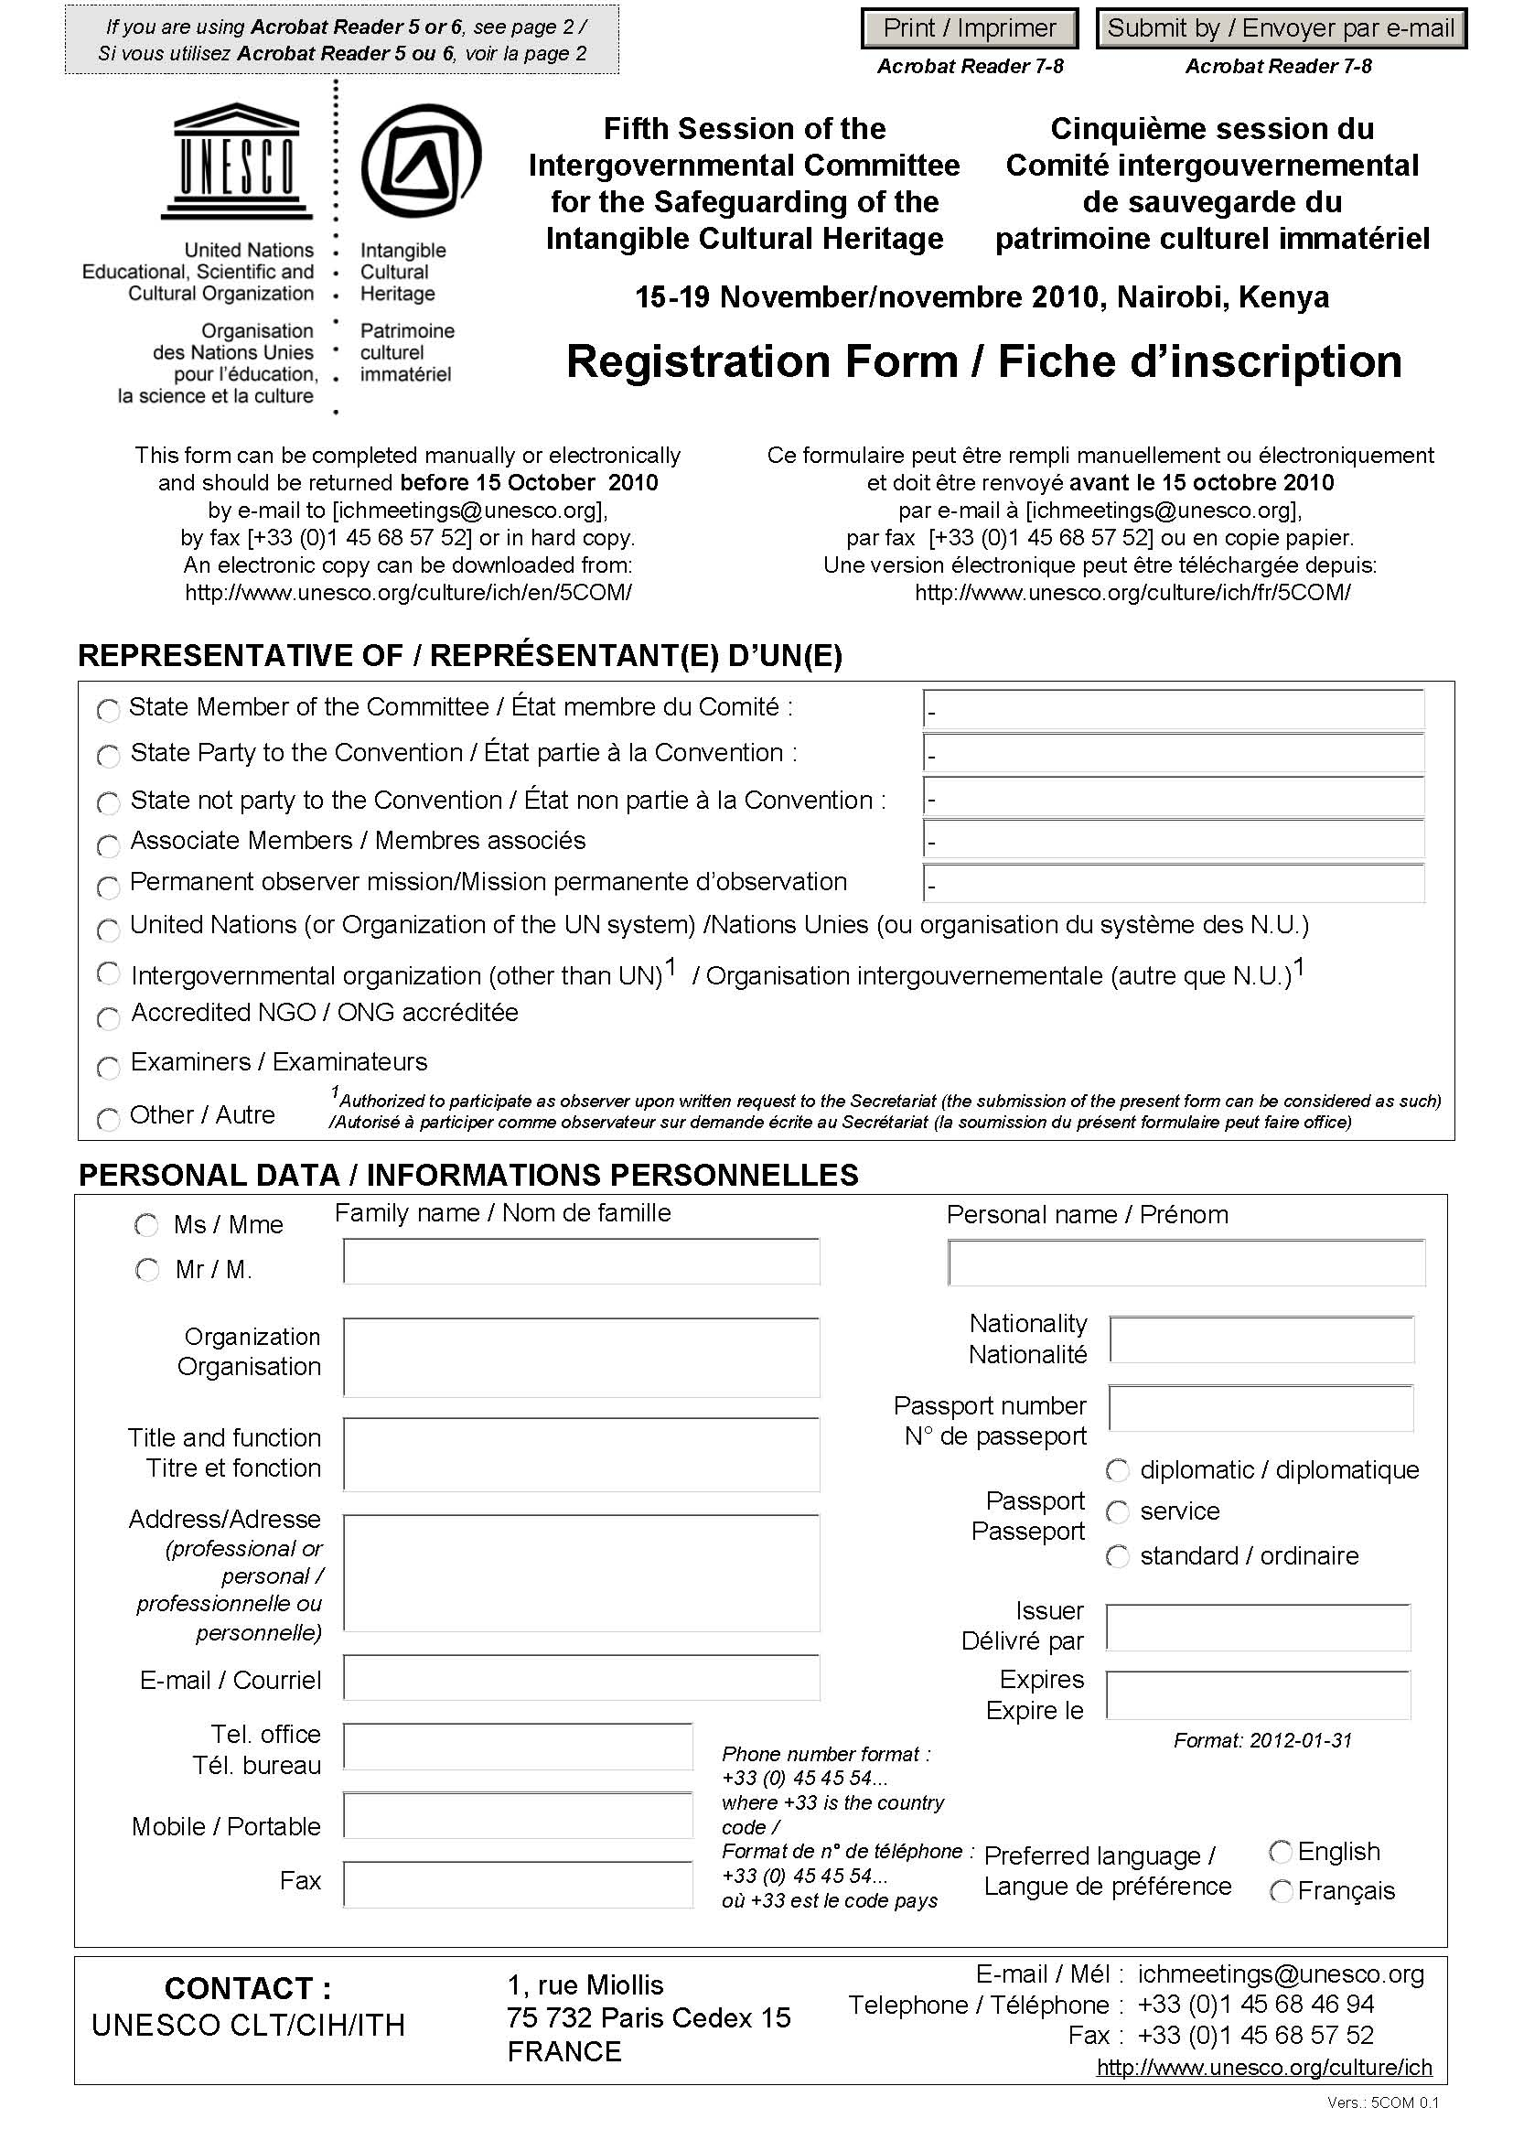

Registration Form (2/2)
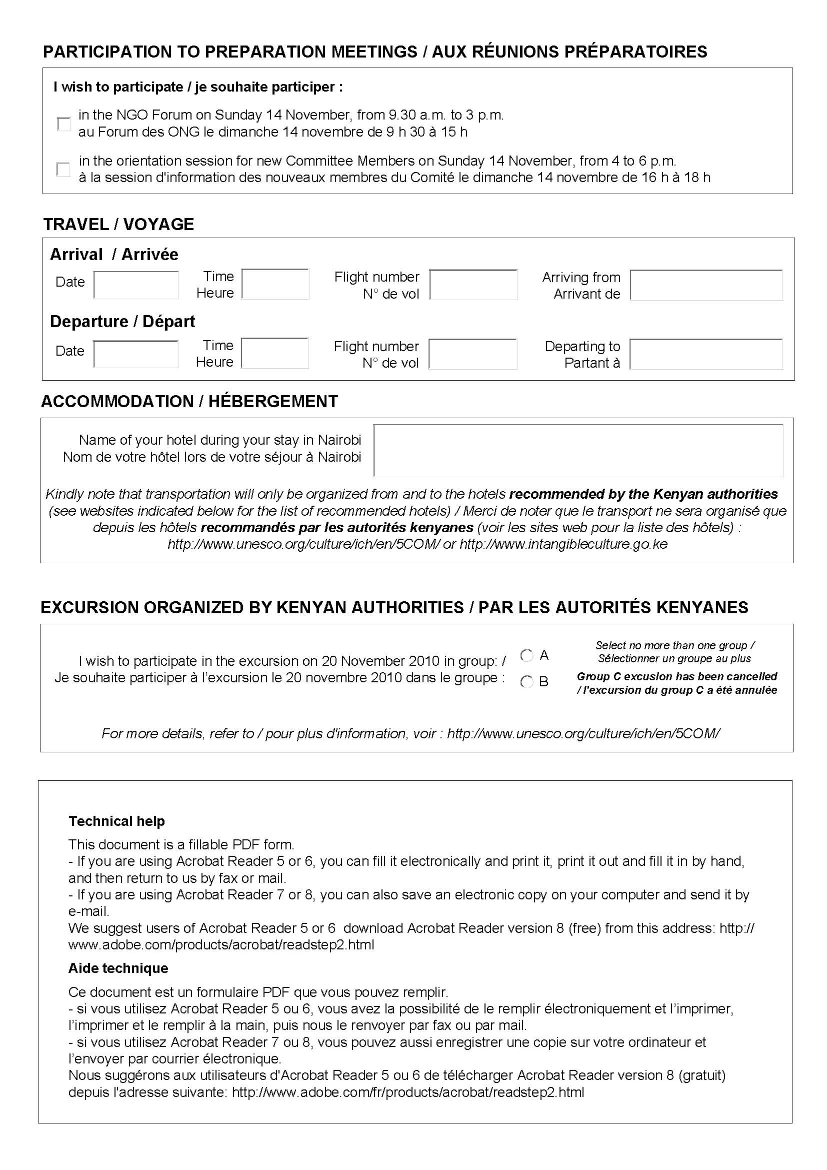

ANNEX B
Recommended Hotels
[additional information available at www.intangibleculture.go.ke ]
Intercontinental Hotel (Five Star)
The InterContinental Nairobi is a superbly equipped hotel located in the heart of Kenya’s capital city. The hotel offers a wide range of both corporate and leisure facilities including a distinguished conference room, outdoor heated swimming pool, 24-hour gym with spa, massage service and sauna. Outdoor pursuits include catering in Nairobi’s National Park. There are 371 air-conditioned rooms with a Presidential Suit, Executive deluxe suites and a Club InterContinental floor. All rooms have en-suite bathrooms, internet link, telephone and TV.

- Address: P.O. Box 30353-00200
- City Hall Way
- Tel: +254 20 32 000 000
- Fax: +254 20 32 000 030
- Email: Sophia.ilako@icnairobi.com,
- Website: www.ichotelsgroup.com,
- Single Superior US$223.40
- Single Deluxe US$275
- The above special rates are inclusive of taxes, bed and breakfast
- Approximately five minute drive to the venue (KICC)
Nairobi Serena Hotel (Five Star)
Renowned for its high standards of efficiency, hospitality and service, the Nairobi Serena Hotel is the flagship of the Serena Hotel Group. Set amid tropical gardens with panoramic views over the park and the downtown skyline, the Serena is an oasis of serenity amid the bustle of one of Africa’s most vibrant capitals. Most rooms have views across the park or the garden. The Nairobi Serena offers a range of fine cuisine including Kenyan, Indian, Italian and Creole. The hotel also has an outdoor swimming pool and a health club as well as modern business and conference facilities.

- Address: P.O. Box 46302-00100
- Kenyatta avenue
- Tel: +254 20 282 2000, +254 20 313 800
- Fax: +254 20 272 5184
- Email: nshreservations@serena.co.ke,
- Website: www.serenahotels.com
- Standard Twin/Double US$220
- Standard Single US$220
- Superior Twin/Double US$395
- Superior Single US$395
- Executive suites US$510
- Breakfast US$30 per person
- Lunch/Dinner US$40 per person
- To enjoy the above special rates delegates should indicate that they will attend UNESCO meeting. The rates are inclusive of taxes and free internet with own laptop.
- Approximately five minute drive to the venue (KICC)

Hilton Nairobi (Five Star)
Hilton Nairobi is currently located in the heart of the business and shopping area of Nairobi. The hotel combines close proximity to the airport with all the advantage of a city-centre hotel. Hilton Nairobi has modern facilities serving 287 rooms, an executive floor and lounge and a business centre. The hotel offers a unique dining experience with four restaurants and two bars offering a variety of menus. Health club facilities include a heated outdoor swimming pool, gymnasium, aerobics, sauna, steam bath and massage.

- Address: P.O. Box 30624-00100
- Mama Ngina Street
- Tel: +254 20 2790000Fax: +254 20 2250099/2226477
- Email: joan.ngure@hilton.com,
- Reservations: www.hilton.com,
- Hilton Guest rooms US$168
- Hilton Deluxe rooms US$208
- Hilton Deluxe Plus rooms US$228
- Hilton Executive rooms US$263
- In town Centre
- The above special rates are inclusive of taxes, access to Health club with gym, outdoor swimming pool, sauna and steam.
- Approximately five minutes drive to the venue (KICC)
Crowne Plaza (Five Star)
- P.O. Box 25574-00100
- Kenya Road, Upperhill
- Tel: +254 20 274 6000
- D/L: +254 20 274 6081
- Fax +254 20 274 6100
- Mobile +254 20 722 247 841
- Email: cynthia.chebii@cpnairobi.com,
- www.cpnairobi.com,
- Standard Single Room US$215
- Superior Single Room US$235
- Deluxe Single Room US$255
- The above special rates are inclusive of tax, free internet, bed and breakfast
- Approximately 20 minutes drive to the venue (KICC)
The Sarova Stanley (Five Star)
The Sarova Stanley is Kenya’s first luxury hotel. It opened its elegant doors in 1902. Since then it has been making history-hosting royal safaris, business events, and legendary personalities such as Edward Prince of Wales, Ernest Hemingway, and Frank Sinatra. Today as the hotel enters its second century; it continues to maintain its unique heritage and provides state-of-the-art services and facilities to business and leisure travellers. The hotel has 217 luxurious guestrooms, including 23 suites, all blending luxurious Victorian grandeur with modern comfort. Spacious club rooms offer deluxe amenities; executive rooms with en-suites lounge and cloakroom. Opulent Presidential, penthouse, and state suites are the pinnacle of luxury. The hotel has three restaurants: the famous Thorn Tree Cafe, the Thai Chi, for authentic Thai cuisine, and the al fresco Pool Deck Restaurant. The past comes to life at The Exchange Bar, former home of Nairobi Stock Exchange, with leather couches and malt whiskies. Other facilities include health club with aerobics, heated pool, massage, sauna and steam room an elegant shopping arcade with curios, suits, eyewear, leather shop, bookshop, pharmacy, and a fully equipped business centre.

- Address: P.O. Box 30680
- Corner of Kimathi Street &Kenyatta Avenue
- Tel: +254 20 275 7000,
- Mobile: +254 722 618 358
- Fax: +254 20 2229 388,
- Email: Arafa.kenji@sarovahotels.com,
- Website: www.sarovahotels.com,
- Deluxe Single US$165
- Deluxe Double US$205
- Club rooms US$225
- Club Double US$265
- The above special rates are inclusive of taxes, complimentary Wi-Fi with own laptop, free use of health club except massage, bed and breakfast
- Approximately 5 minutes drive to venue (KICC)
Fairview Hotel (Four Star)
The Fairview- ‘the country hotel in town’ – is set in five acres of landscaped gardens, five minutes from downtown Nairobi. Owned and managed since 1946 by one family, the Fairview is a charming blend of past and present. Guest rooms all have spacious bathrooms, satellite TVs and large electronic safes. Furnished apartment apartments are available for long-term residents. There is a 25-metre swimming pool and a gym.

- Address: P.O. Box 40842-00100
- Bishops Road
- Tel: +254 20 288 1000
- Fax: +254 20 272 1320
- Email: book@fairviewkenya.com,
- Website: www.fairviewkenya.com,

Single Room Alternatives

- Economy Kshs. 10,400= US$139
- Economy plus Kshs. 11,600= US$155
- Business Kshs. 12,900= US$172
- First Kshs. 14,400= US$192

Double Room Alternatives

- Economy (2 persons) Kshs. 13,400= US$179
- Business (2 persons) Kshs. 15,300= US$204
- First (2 persons) Kshs. 16,400= US$219
- Credit card guarantee (or a deposit) is required to reserve room
- 24 hours notice of cancellation or amendments is required for less than 2 rooms
- The above special rates are inclusive of bed and breakfast, Wi-Fi and all taxes
- Approximately 10 minutes drive to the venue (KICC)
Sarova Panafric Nairobi (Four Star)
Imposingly set in a quiet residential suburb of Nairobi, the Sarova Panafric commands a panoramic view of the Kenyan capital. The hotels rooms have satellite TV, internet and a 24-hour room service. The hotel is famed for its excellent local and international cuisine, sumptuous buffets, tantalising barbecue and extensive a’ la carte menu. It is also a home to the Flame Tree Restaurant, dubbed ‘the finest restaurant in town’.

- Address: P.O. Box 30486-00100
- Tel: +254 20 2720822
- Mobile: +254 722 618 358
- Email: Arafa.kenji@sarovahotels.com,
- Website: www.sarovahotels.com,
- Standard Single Room US$120
- Superior Single Room US$ 135
- A maximum of five hours response to Credit Card Reservation
- The above special rates are inclusive of taxes, complimentary Wi-Fi with own laptop, free use of health club except massage, bed and breakfast
- Approximately 10 minutes drive to the venue (KICC)
Silver Springs Hotel (Three Star)
Silver Springs hotel is a deluxe 3-star luxurious hotel surrounded by tranquillity and serenity, marked with evergreen trees, beautiful flowers and medicinal plants. The hotel has tastefully furnished rooms with digital safes and electronic card locks. The newly opened ‘Silver Nest Wing’ is part of Silver Springs Hotel’s effort to consolidate its position as an excellent and unique hospitality destination and offers pure luxury. Facilities include a restaurant serving delicious meals and beverages, conference facilities and a modern health club.

- Address: P.O. Box 6132-00100
- Argwings Kodhek Road
- Tel: +254 20 2722451/2/3/4/6/7
- Fax: +254 20 2720545/2728061
- Mobile: +254 722 204870, +254 721 265086, +254 725 474 308
- Email: sales@silversprings-hotel.com, silversprings@iconnect.co.ke,
- Website: www.silversprings.hotel.com,
- Standard Single: Kshs. 9,000= US$120
- Standard Double: Kshs. 12,000= US$160
- Superior Single: Kshs. 12,500= US$167
- Superior Double: 15,500= US$207
- Panorama: Kshs. 15,000 =US$200
- The above special rates are inclusive of tax, free internet, bed and breakfast
- Approximately 15 minutes drive to the venue (KICC)

ANNEX C
Location of KICC
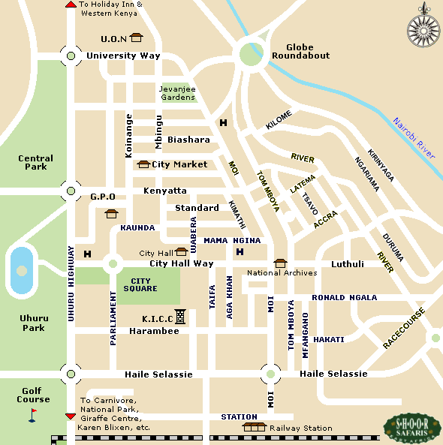

Note: Google for your hotel site

